APPLICATION OF COMPUTATIONAL NUMERICAL TECHNIQUES FOR DEMAND FORECASTING IN ENGINEERING MANAGEMENT
TABLE OF CONTENTS
1.0 Introduction 2
2.0 Key Concepts of Mathematical Modelling in Engineering Management (LO1) 3
2.1 Mathematical Modelling in Managerial Decision-Making 3
2.2 Relevance of Mathematical Models for Complex Problems 4
3.0 Case Study Selection and Problem Formulation (LO1 & LO3) 5
3.1 Description of the Engineering Management Problem 5
3.2 Mathematical Formulation of the Problem 6
4.0 Numerical Techniques and Computational Implementation (LO2 & LO4) 7
4.1 Selection and Justification of Numerical Methods 7
4.2 Custom Numerical Method: Linear Regression (Normal Equation) 8
4.3 Built-in Numerical Methods Using Python 10
5.0 Numerical Results, Error Analysis and Comparison (LO3) 13
5.1 Accuracy and Error Measurement 13
5.2 Stability, Efficiency and Decision Impact 16
6.0 Role of Numerical Software in Engineering Management Decisions (LO4) 17
7.0 Conclusion 18
Reference List 19
Appendices 21
Appendix 1: Dataset Link 21
Appendix 2: Google Colab Link 22
Appendix 3: Python Full Code 23

1.0 Introduction
Engineering management is often characterised by making decisions in uncertain, complex, and dynamic market conditions. In making decisions about production planning, inventory control, pricing objectives, and resource allocation, managers are required to make well-informed decisions with incomplete or changing information being provided. Non-linearity, interdependency of variables and stochastic effects in the real-world system that require traditional analytical solutions based on closed-form mathematical expressions often prove inadequate in these settings. Numerical techniques offer a sensible way to beat these shortcomings by learners to obtain approximate answers by a sequence of computations. Such techniques enable both the complex relationships to be modelled based on the real world data and thus enhance the accuracy of the decision.
Demand forecasting is a very important use of the number in engineering management because incorrect demand forecasting may cause overstocking, stockout and monetary shortcoming. A demand forecasting case problem is used in this report, whereby numerical regression is used with Python as the computing tool. Python allows performing data processing, implementing the model, and visualising it, which is why the language is chosen to ensure the management, analysis, and engineering. The paper, therefore, indicates the way in which numerical techniques could build evidence-based managerial judgments in complex environments.
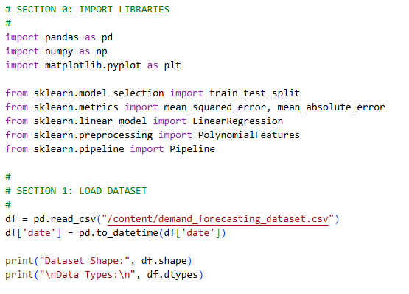
Figure 1: Dataset Importation
(Source: Self-created in Google Colab)
Figure 1 shows a successful demand forecasting dataset importation and examination at Google Colab. The data set has 4999 observations and 20 variables, which is enough for numerical modelling. The variables will be the numerical variables, categorical variables (boolean) and non-numerical variables (in the form of time). There are no values lost, and the subsequent regression analysis would be numerically stable and reliable. This streamlined dataset can be computed to provide invalid decision-making at the managerial level of engineering.

2.0 Key Concepts of Mathematical Modelling in Engineering Management (LO1)

2.1 Mathematical Modelling in Managerial Decision-Making
The term mathematical modelling is defined as a process of describing real-world systems in mathematical expressions in order to study behaviour, predict trends and aid decision making. Mathematical models are very popular in the field of engineering management,t where they are used in forecasting, optimisation, scheduling and risk assessment. According to Aldahmani et al. (2024), regression-based models prove to be highly effective when it comes to illustrating the relationship between dependent and independent variables within operational systems. Managerial models are often defined by their inputs, which are values or variables of the economy or the price that are determined, a computation framework that connects these inputs, and a final output that is used to make a decision.
Models do, however involve assumptions ansimplificationson such as linearity or independence,e to be economically calculable. Such simplifications enable complex systems to be analysed at a reasonable cost in terms of computation. Such abstractions, according to Anvarjonov (2024), are needed in order to achieve a balance between the accuracy of the model and interpretability in managerial situations. Engineering mathematical modelling assists engineering managers by suggesting the evaluation of scenarios and sensitivity analysis. The simulator is beneficial in letting the managers predict the risks and the best strategies by simulating the effect of changes in key variables on the outcome. Thus, mathematical models are a point between quantitative analysis and the implementation of the decision-making process.

2.2 Relevance of Mathematical Models for Complex Problems
Engineering problems in the real world tend to be uncertain, varying and lack complete information, and it is not feasible to find an exact mathematical answer. As a result, the use of numerical approximation is necessary in non-linear relations or largeamounts of data. According to Vinayaga et al., numerical models enable the analysis of complex systems in the presence of uncertainty by approximating behaviour instead of solving equations (2025). Uncertainty modelling in the context of engineering management allows making quality strategic and operational decisions regarding the fluctuations of demand and the market conditions. More specifically, forecasting models assist organisations in being proactive when it comes to responding to variability. Mathematical modelling is therefore critical in addressing the complexity and aiding informed decision-making.
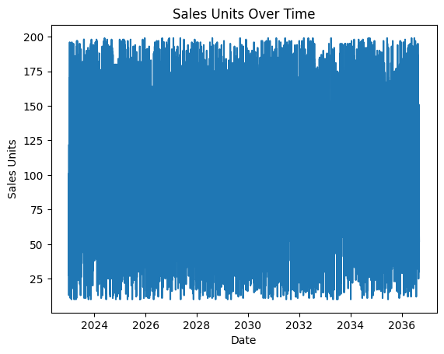
Figure 2: Sales Units Over Time
(Source: Self-created in Google Colab)
The pattern of the sales units over time, as it is shown in Figure 2, demonstrates the variability in the product demand during the time interval under consideration. Its sales volume per unit is 103.29, meaning that the demand is medium and changes periodically. Such variations explain why numerical forecasting techniques should be used as opposed to plain descriptive analysis. Knowledge of temporal sales behaviour helps the engineering managers in capacity planning, inventory control and scheduling of operations, particularly in situations where non-uniform demand patterns with time exist.

3.0 Case Study Selection and Problem Formulation (LO1 & LO3)

3.1 Description of the Engineering Management Problem
One of the most important engineering management problems is demand forecasting because it directly influences the process of inventory management, pricing, and promotion planning. Wrong predictions can lead to financial losses and poor operation. According to El Jaouhari et al (2022), demand forecasting that is effective enhances coordination between the demand and supply, as well as minimising wastefulness. The dataset that is used in this study is structured with the data on sales, pricing, promotional and economic and environmental variables. The important variables will be price, discount percentage, promotion indicators, economic indices, competitor pricing and the effect of weather. Demand is the future dependent variable. Its dataset is realistic in that it illustrates dynamics in demand in relation to various factors influencing the demand, and as such, it can be analysed numerically. The engineering managers will be able to analyse these variables to get a better idea of demand behaviour and enhance decision-making during planning.

3.2 Mathematical Formulation of the Problem
The forecasting of demand is also formulated as follows: the future demand is defined as a response to various factors. Future demand is the dependent variable, whereas price, discount percentage, application of promotion, economic index, competitor price index, and all weather effects are the independent variables.
This association can be described as follows:
Demand [Future] = f(Price, Discount, Promotion, Economy, Competition, Weather)

According to Ifraz et al. (2023), formulations of regressions are appropriate in the capture of the linear and non-linear relationships in demand forecasting. This expression is such that the numerical methods of approximation will give an estimate of the functional relationship among variables. Since actual demand trends are complex, a numerical regression is an efficient solution in cases where the use of the analysis tools is not feasible.
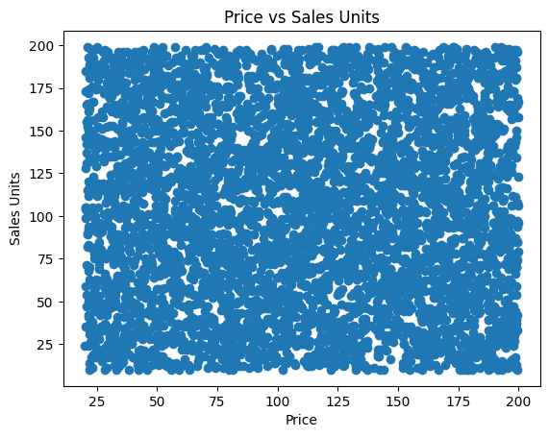
Figure 3: Price vs Sales Units
(Source: Self-created in Google Colab)
Figure 3 analyses the correlation between the product price and the sales units based on a scatter diagram. The calculated value of the correlation coefficient of 0.0015 represents a very weak linear relationship between price and sales volume. It means that price is not a critical factor affecting sales demand in this data set. Engineering managers, therefore have to factor in more variables like promotions, economic status and competition in predicting demand, and this is the reason multivariate numerical models are important.

4.0 Numerical Techniques and Computational Implementation (LO2 & LO4)

4.1 Selection and Justification of Numerical Methods
Numerical methods of forecasting, in particular regression, are popular because of their interpretability and the efficiency with which they can be computed. Linear regression is a base-level method with a basis of modelling linear relations between variables, and thus it is appropriate for the interpretations of managers. According to Aldahmani et al. (2024), a linear regression is useful in demand forecasting when there must be transparency. Polynomial regression can be seen as an extension of linear models with greater flexibility obtained at the cost of a more complex model. One of the most important issues that engineering managers should consider is the trade-off between accuracy and simplicity. Easy to interpret, simpler models exist, whereas complex models might have slight improvements in accuracy. Thus, the techniques of both linear and polynomial regression can be used in comparative numeric research in this case.

4.2 Custom Numerical Method: Linear Regression (Normal Equation)
The normal equation is the custom numerical technique applied in this research to estimate the regression coefficients. Normal equation calculates the parameters using analytical computations in the form of a matrix, hence it can be solved directly without the need to optimise parameters iteratively. According to Anvarjonov (2024), tailor-made implementations allow improving the awareness of numerical stability and algorithm behaviour. A manual implementation of regression offers an insight into the way to implement the related computational procedure and confirm findings represented by software programmers.
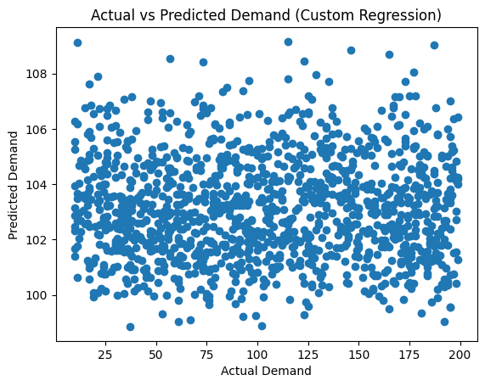
Figure 4: Actual vs Predicted (Custom Regression)
(Source: Self-created in Google Colab)
Figure 4 assigns actual values of future demands and the values that are estimated using the custom linear regression model. The standard deviation of the points around the line of projection shows the accuracy of the prediction. This model has an RMSE of 54.91 and an MAE of 47.50, which means that it forecasts with moderate error. According to these results, it is seen that the modified version of this numerical implementation based on the normal equation is a reasonable approximation of the demand, but it proves that the mathematical one is correctly formulated.

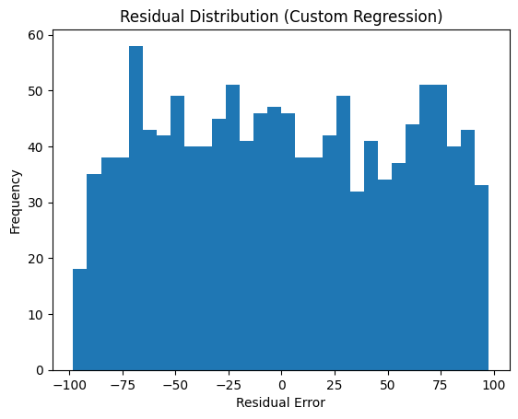
Figure 5: Residual Distribution (Custom Regression)
(Source: Self-created in Google Colab)
Figure 5 shows the distribution of the residual errors generated using the custom regression model. The residuals are equally distributed about zero, which implies stability of the numbers and no systematic bias is present. Even though the amount of error is still a significant one, the pattern of residuals makes it possible to state the fact that the assumptions of the model are plausible. Critical analysis for the engineering managers is that the constant behaviour in the residues increases confidence in using the numerical outputs in making strategic forecasting decisions.

4.3 Built-in Numerical Methods Using Python
The scikit-learn Python library contains efficient numerical regression methods. Linear regression is an automatic parameter estimation that is also numerically stable. Polynomial regression is an extension of this method that allows non-linear transformations. According to Yan (2025), Python-based numerical libraries improve the efficiency and minimise the error of implementation in engineering analysis. The ability to conduct comparisons and experiments quickly in relation to software automation facilitates informed decisions regarding the business by the managers. Use of automated tools is, however dependent on the knowledge of assumptions.
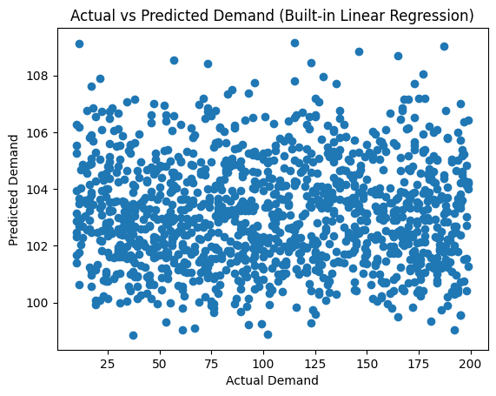
Figure 6: Actual vs Predicted (Built-in Linear Regression)
(Source: Self-created in Google Colab)
The comparison of the values in Figure 6 between the actual demand and those of the built-in linear regression model shows a strong similarity. Figure 4 has a visual similarity that validates the consistency between software-implemented and custom numerical implementations. The constructed model also generates the same error measures (RMSE = 54.91, MAE = 47.50), which confirms the correctness of the numbers. This shows the accuracy of computational facilities in Python in the engineering analysis of management and gives a reason to trust automated modelling procedures.

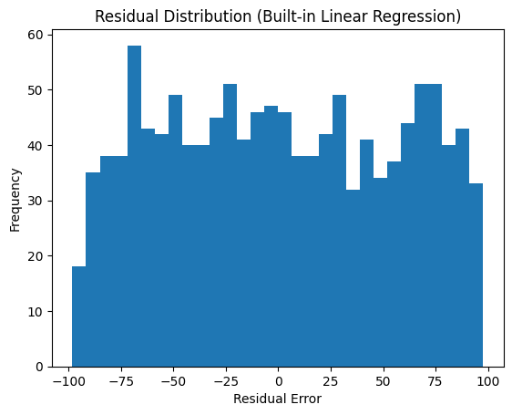
Figure 7: Residual Distribution (Built-in Linear Regression)
(Source: Self-created in Google Colab)
The distribution of the residual error is shown in Figure 7 to represent the built-in linear regression model. The distribution is almost similar to that of the custom regression, which supports the numerical equivalence of the two strategies. Symmetry about the point of zero indicates that the estimation process is stable, and there is no systematic over- or under- prediction. This uniformity is crucial in the engineering decision-making process because it ensures that the custom and the built-in numerical methods can be relied upon for forecasting purposes.

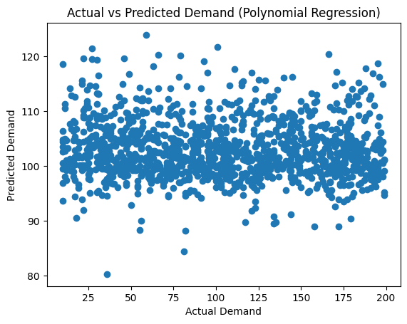
Figure 8: Actual vs Predicted (Polynomial Regression)
(Source: Self-created in Google Colab)
Figure 8 demonstrates the dependence of the actual demand and scaled predictions of the regulatory model of the polynomial regression. Although the model has introduced a non-linear feature, it has a slightly greater RMS, E, as it is 55.38 and a slightly greater M, AE, as it is 47.80. That means that the more complex the model is, the better the results may not be. The outcome provides a valuable engineering management lesson: more sophisticated numerical algorithms might be more unstable,ble but they might not come with corresponding performance improvements.

5.0 Numerical Results, Error Analysis and Comparison (LO3)

5.1 Accuracy and Error Measurement
Root Mean Squared Error (RMSE) and Mean Absolute Error (MAE) are used to assess the model performance. RMSE is more severely punitive of big mistakes, whereas MAE gives a mean scale of prediction error. According to Ifraz et al. (2023), the evaluation of a forecast is enhanced by combining various metrics of errors. Numbers obtained have shown that the custom and built-in linear regression models have the same value in terms of RMSE and MAE, which is a sign of numerical consistency. Polynomialy regression gives a slightly larger value of errors, meaning that the non-linear enhancement is not so high in this data set. These results indicate that as complexity increases, performance may not be a better outcome. As such, linear regression provides an accurate and interpretable solution.
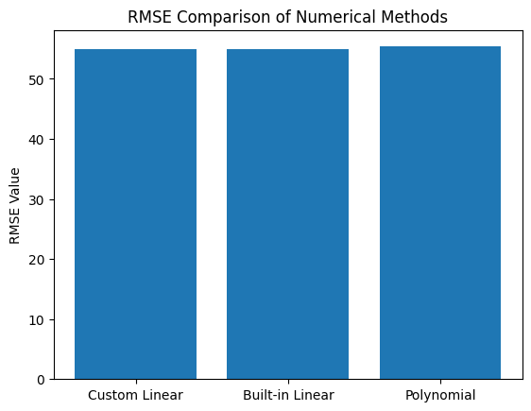
Figure 9: RMSE Comparison of Numerical Methods
(Source: Self-created in Google Colab)
Figure 9 will compare the Root Mean Square Error (RMSE) in three numerical methods. The custom and built-in linear regression models all report an RMSE of 54.91, whereas the value of the RMSE is higher in the case of the polynomial regression model at 55.38. This comparison proves the fact that linear approaches are more efficient in this dataset. This type of numerical assessment can help engineering managers to choose the best forecasting models in terms of accuracy, and not complexity.
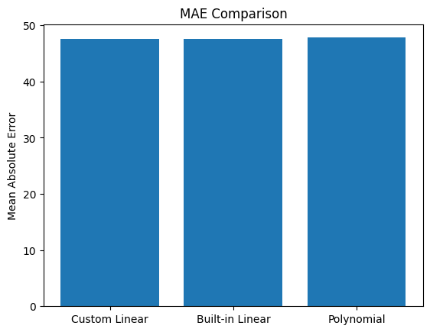
Figure 10: MAE Comparison
(Source: Self-created in Google Colab)
A comparison of the values of Mean Absolute Error (MAE) of all the numerical models is shown in Figure 10. The custom and built-in linear regression approaches yield the lowest MAE of 47.50, and the highest MAE of 47.80 is attained in the poly regression approach. The smaller values of MAE show the enhanced average prediction value, which confirms the appropriateness of the linear regression used in the specified scenario as a method of demand forecasting. The comparison validates the data-driven model selection in making managerial decisions.
Model Type | RMSE Value | MAE Value | Model Complexity | Managerial Interpretability
Custom Linear Regression | 54.91 | 47.50 | Low | High
Built-in Linear Regression | 54.91 | 47.50 | Low | High
Polynomial Regression (Degree 2) | 55.38 | 47.80 | Moderate | Medium

Table 1: Comparison of Numerical Forecasting Models Based on Error Metrics
(Source: Self-created)
The evaluation of the numerical forecasting model based on the root mean Square error (RMSE), mean absolute error (MAE), model complexity and managerial interpretability is given in Table 1. The findings reveal that the custom linear regression and the built-in linear regression models have the same value of RMSE and MAE, thus indicating that the numerical consistency between manual and automated software is not violated. The values of the error in the poly regression model are slightly higher, which is the fact that the predictive abilities are slightly lower, even though the complexity of the regression model is greater. This result implies that the addition of non-linearity does not always enhance the performance of the forecasting of the chosen sample.

5.2 Stability, Efficiency and Decision Impact
Residual distributions show there is no centre of action in the behaviour of the model, such that errors are localised about zero. The stability implies that regression assumptions are well-prescribed. According to Meyer and Reniers (2022), modelling based on stability boosts trust in the engineering decision-making process. Efficiency-wise, linear regression is very efficient, as minimal computation is needed in linear regression; it can be applied in real-time applications. The errors in forecasting have a direct impact on inventory and pricing decisions, in which overestimation may result in higher holding costs, and underestimation may lead to stockouts. Computational efficiency is also measured by putting algorithms and model speeds in a comparison, which indicates the benefits of linear regression with high scale. Linear regression is very interpretable and efficient, whereas the extent of the complexity is better at the cost of the consequences, such as the need to use caution when choosing to use a polynomial regression based on the business situation. As a result, the operation is efficient and strategic planning is supported with reliable numerical forecasting.
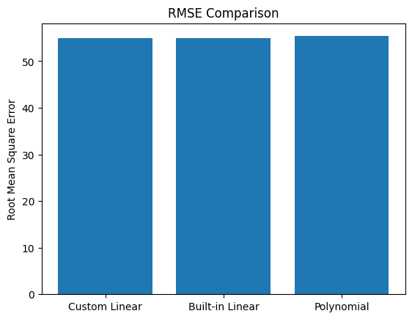
Figure 11: RMSE Comparison
(Source: Self-created in Google Colab)
Figure 11 further supports the comparison of the evaluation of numerical methods by displaying the differences in RMSE. Numerical consistency is established by the equality of RMSE of custom and built-in linear regression, and reduced efficiency is indicated by the higher RMSE value of a higher order of the polynomials. This value illustrates that the more basic numerical methods may be more efficient than the complicated onsets in agreement with data properties. These insights can be important in case where at an engineering manager seeks to make a tradeoff between computational efficiency, accuracy, and interpretability.

6.0 Role of Numerical Software in Engineering Management Decisions (LO4)
Python offers a solid framework for the formation of numerical data, data manipulation, and data visualisation. It can be customised and automated, which allows result validation due to its flexibility. According to Yan (2025), numerical software enhances confidence in the decision through the minimisation of computational errors. Model reliability is confirmed by the similarity of the custom and built-in results of regression processes. Nonetheless, the tools used in numbing are still subject to data quality and assumptions of the model. Nonetheless, the constraints notwithstanding, software-intensive numerical approaches are also capable of greatly boosting the engineering management decision-making process in terms of evidence-based analysis. Even though Python allows quick modelling and validation, its forecasting accuracy is limited by the data quality, assumptions and possible risks of overfitting the model.

7.0 Conclusion
This paper was able to reveal how numerical techniques can be used in demand forecasting in an engineering management case. Regression-based models were good at modelling the relationship between demand and defining factors. Linear regression methods were consistent and reliable, as confirmed by numerical results. Therefore, analytical methods do not work with complex managerial problems, and in such cases, numerical methods give viable solutions. The results re-establish the value of a computational tool in assisting in making informed engineering management decisions.

Reference List
Aldahmani, E., Alzubi, A. and Iyiola, K., 2024. Demand Forecasting in Supply Chain Using Uni-Regression Deep Approximate Forecasting Model. Applied Sciences, 14(18), p.8110.https://www.mdpi.com/2076-3417/14/18/8110
Amini, M. and Jahanbakhsh Javid, N., 2023. A multi-perspective framework established on diffusion of innovation (DOI) theory and technology, organization and environment (TOE) framework toward supply chain management system based on cloud computing technology for small and medium enterprises. Organization and Environment (TOE) Framework Toward Supply Chain Management System Based on Cloud Computing Technology for Small and Medium Enterprises (January 2023). International Journal of Information Technology and Innovation Adoption, 11, pp.1217-1234.https://papers.ssrn.com/sol3/papers.cfm?abstract_id=4340207
Anvarjonov, B., 2024. Enhancing business financial calculations with Python: A practical approach. Modern Science and Research, 3(6).https://inlibrary.uz/index.php/science-research/article/view/33845
El Jaouhari, A., Alhilali, Z., Arif, J., Fellaki, S., Amejwal, M. and Azzouz, K., 2022. Demand forecasting application with regression and IoT-based inventory management system: a case study of a semiconductor manufacturing company. International Journal of engineering research in africa, 60, pp.189-210.https://www.scientific.net/JERA.60.189
Ifraz, M., Aktepe, A., Ersöz, S. and Çetinyokuş, T., 2023. Demand forecasting of spare parts with regression and machine learning methods: Application in a bus fleet. Journal of Engineering Research, 11(2), p.100057.https://www.sciencedirect.com/science/article/pii/S2307187723000585
Jääskä, E. and Aaltonen, K., 2022. Teachers’ experiences of using game-based learning methods in project management in higher education. Project Leadership and Society, 3, p.100041.https://www.sciencedirect.com/science/article/pii/S2666721522000011
Kumar, V., Kedam, N., Sharma, K.V., Mehta, D.J. and Caloiero, T., 2023. Advanced machine learning techniques to improve hydrological prediction: A comparative analysis of streamflow prediction models. Water, 15(14), p.2572.https://www.mdpi.com/2073-4441/15/14/2572
Lyu, Z., Yu, Y., Samali, B., Rashidi, M., Mohammadi, M., Nguyen, T.N. and Nguyen, A., 2022. Back-propagation neural network optimised by K-fold cross-validation for prediction of torsional strength of reinforced Concrete beam. Materials, 15(4), p.1477.https://www.mdpi.com/1996-1944/15/4/1477
Meyer, T. and Reniers, G., 2022. Engineering risk management. Walter de Gruyter GmbH & Co KG.https://books.google.com/books?hl=en&lr=&id=NYpnEAAAQBAJ&oi=fnd&pg=PR5&dq=%E2%80%9CApplications+of+Linear+Regression+in+Engineering+and+Management+Systems&ots=W25RHu0YOp&sig=aWQroh36PTQ-GmFYZhSIBqzNyds
Reiff, J. and Schlegel, D., 2022. Hybrid project management–a systematic literature review. International journal of information systems and project management, 10(2), pp.45-63.https://aisel.aisnet.org/ijispm/vol10/iss2/4/
Taboada, I., Daneshpajouh, A., Toledo, N. and De Vass, T., 2023. Artificial intelligence-enabled project management: a systematic literature review. Applied Sciences, 13(8), p.5014.https://www.mdpi.com/2076-3417/13/8/5014
Villarreal, E.R.D., García-Alonso, J., Moguel, E. and Alegría, J.A.H., 2023. Blockchain for healthcare management systems: A survey on interoperability and security. IEEE Access, 11, pp.5629-5652.https://ieeexplore.ieee.org/abstract/document/10015729/
Vinayaga, P., Senthilkumar, C.B. and Perumal, A.I., 2025. Modelling Multi-Variable Business Forecast Trends Using Interpretive Ordinary Differential Equations. Metallurgical and Materials Engineering, pp.1144-1153.https://www.metall-mater-eng.com/index.php/home/article/view/1683
Vu, H.L., Ng, K.T.W., Richter, A. and An, C., 2022. Analysis of input set characteristics and variances on k-fold cross-validation for a Recurrent Neural Network model on waste disposal rate estimation. Journal of Environmental Management, 311, p.114869.https://www.sciencedirect.com/science/article/pii/S030147972200442X
Yan, Q., 2025. Research on the Application of Python Big Data in Financial Analysis. Risk and Financial Management, 6(1), pp.p109-p109.https://j.ideasspread.org/index.php/rfm/article/view/1585

Appendices

Appendix 1: Dataset Link
https://www.kaggle.com/datasets/ziya07/strategic-supply-chain-demand-forecasting-dataset

Appendix 2: Google Colab Link
https://colab.research.google.com/drive/16htbpUaYxckswHa7Fh-TEA0jnr0tmciG?usp=sharing

Appendix 3: Python Full Code
